Race Plan for IM 70.3 Santa Rosa – 13 May 2017

Goal: Santa Rosa 70.3 - 2112 yard swim / 56 mile bike / 13.1 mile run
    - “A” Goal – Swim 34:30, Bike 2:22-2:28, Run 1:28-1:31: <=4:30-4:35
    - “B” Goal – Swim 35:30, Bike 2:29-2:35, Run 1:32-1:35: <=4:36-4:45
    - “C” Goal – Swim 36:30, Bike 2:36-2:45, Run 1:35-1:38: <=4:46-5:00

Projected weather: 67 degrees, ~72% humidity, Winds WSW 10mph

History on this course: 1st raced Vineman 70.3 in July 2015 (4:56), first time at this new course

Pre-race prep:
Monday – Easy spin, run with 6x400 @ 10k pace
Tuesday – Easy swim, bike with 4x90 secs
Wednesday – Easy swim, Run with 4x400 @ 10k pace
Thursday – rest day, driving down to pick up Julia at airport early, then head to expo to pick up packets and scope out event
Friday – Easy bike, easy run, drop off bike and run gear. Early lunch and dinner then sleep.

Equipment:
Swim - Full sleeve ROKA wetsuit, Aquasphere Cayenne Tinted Goggles, race cap, foggle/anti-fog stick, RoadID wristband, D3 Trisuit, Garmin 920XT watch, heart rate monitor
Bike - Specialized Shiv bike with front/rear Roval race wheels, continental gps 2 tires (25mm) with latex tubes + extenders, 2 rear bottles 24oz bottles (old gatorade bottles), Garmin Edge 1000, Giro Aerohead Helmet, bike shoes, bike top tube bento bag w/ gu and salt pills
Run – Altra running shoes with running socks, hat, Oakley sunglasses, race belt with number, run bottle with salt pills and gu in side pocket filled with coke

Nutrition:

Thursday, May 11: Carb load day – heavy breakfast (pancakes, eggs, sausage, bacon, etc), carb lunch, pizza dinner
Friday, May 12: heavy breakfast (IHOP), medium lunch with veggies, Olive Garden Soup and Salad or lighter meal at home, will keep it medium (est 2000-2500 calories)
Morning of (May 13):
Able to cook - 2 eggs, english muffin, almond butter, honey, almond milk, banana, coffee (need 800-1000 calories)

Race Nutrition
Taking this from Nick's 70.3 Plan I used in Vineman 70.3 (2015) and Superfrog 70.3 (2016) / Oceanside 2017 – worked like a charm

Swim – 15 min prior, 1x gu, 1x salt pill, 12 oz water

Bike:
Hour 1 – 40 oz Gatorade Endurance + 3 salt tabs + 8 oz water
Hour 2 – 40 oz Gatorade Endurance + 4 salt tabs + 8 oz water
Hour 3 - 24 oz Gatorade Endurance + 2 salt tabs + 8 oz water + gu / heavy caffeine version (mile 51)

Run:
Hour 1 – 8 oz Gatorade Endurance + 5 salt tabs + 1 gu heavy caffeine version (first 30 min) + 16 oz water + 4 oz coke
Hour 2 – 8 oz Gatorade Endurance + 3 salt tabs + 4 oz coke + 10 oz water + ½ gel

**Note** - Based on Oceanside 2017, I’m hand carrying a bottle filled with coke and will start that right away – I need it

Racing/Pacing:

Swim – I was flat at Oceanside but not tired when I exited (~36:50). I’ll need to hit it hard and fast right away then just hang on instead of cruise.

T-1 – From what I’ve seen, this will suck. There’s a straight uphill run for quite a bit of distance to get to the bikes, so this may be like Oceanside (~4:00)

Bike – I did alright at this course in the past on weak watts, so hopefully this time will be much better. Based on Oceanside’s bike, I need to push harder as I held back quite a bit – need to get the bike around 200 TSS.

Here is the bike from July 2015 - http://tpks.ws/7BVS4
I had just gotten re-fit on the bike and everything was off so my wattage was pretty weak. However, I did this on low TSS and still did a 2:40.
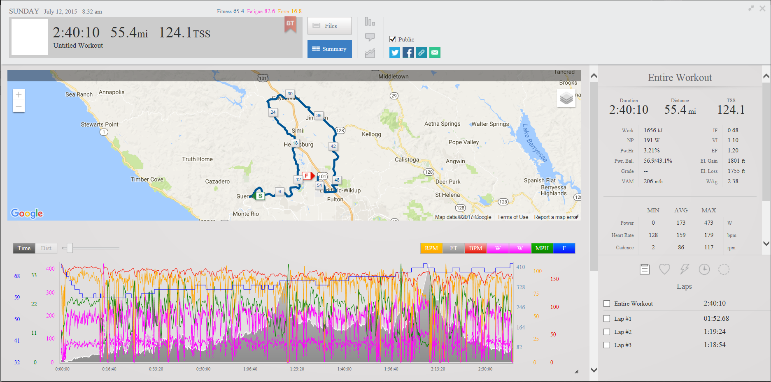

I’ve gotten a bit better since July 2015 (more aero, more fit) so I expect that I’ll do well on this course. I just need to make sure I can summon up my full power in aero and sustain it, so I’m aiming for 220-230 watts.

Here’s the BBS:
https://www.bestbikesplit.com/public/55639

I set this to 0.82 IF based on an FTP of 270:

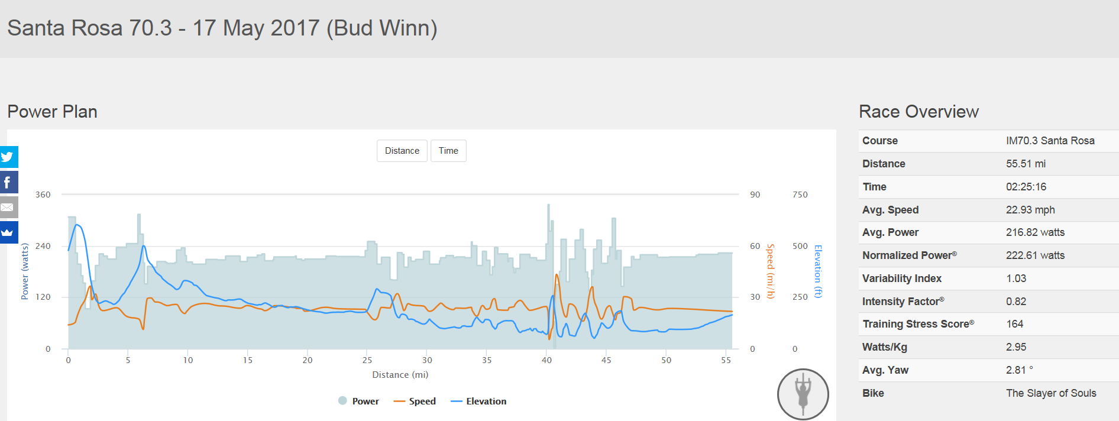

T-2: This may be a boondoggle, so I’m just aiming to clear this pretty fast. Oceanside was quick so I think I’m alright here.

Run: I’ve done alright at this run in the past and I think my fitness is there, I just need to make sure I’m fueled up.

Here are the Vineman 2015 results - http://tpks.ws/KsXTJ

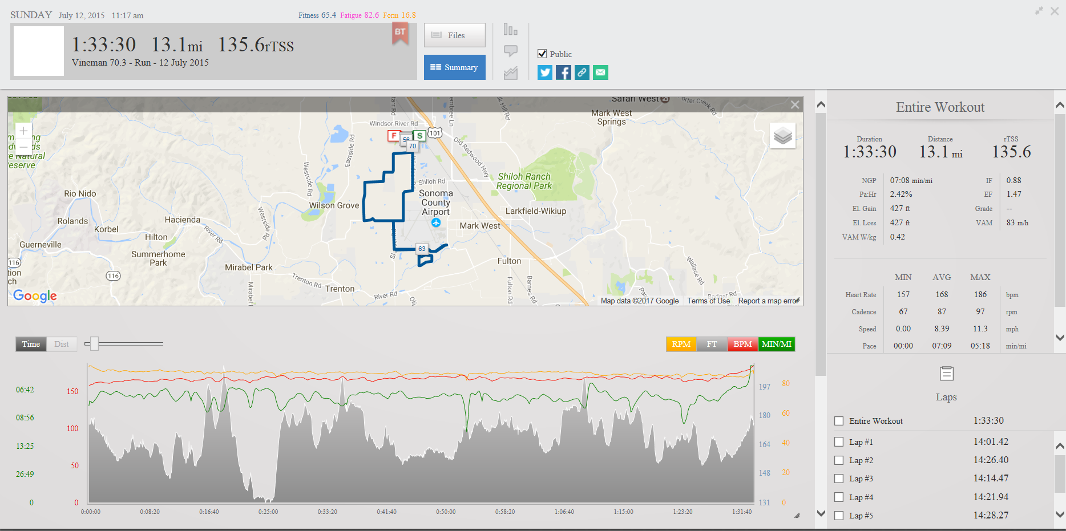

My HR was about where I expected since I was fueled up – I was able to push this one in the past quite well. Looking forward to beating this time and hopefully going sub-1:30.

Overall, I’m looking for revenge from Oceanside and seeing if I can get under sub-4:50 finally.

