Race Plan for IM 70.3 Oceanside – 1 April 2017

Goal: Oceanside 70.3 - 2112 yard swim / 56 mile bike / 13.1 mile run
    - “A” Goal – Swim 33:30 (1:35/100y), Bike 2:30, Run 1:28: <=4:35
    - “B” Goal – Swim 35:30 (1:41/100y), Bike 2:40, Run 1:32: <=4:51
    - “C” Goal – Swim 36:30 (1:44/100y), Bike 2:50, Run 1:35: <=5:04

Projected weather: 67 degrees, ~72% humidity, Winds WSW 10mph

History on this course: 1st raced in March 2014 (5:40); 2nd race in 2015 (5:20); spectated/Sherpa in 2016

Pre-race prep:
Monday – Easy spin, run with 6x400 @ 10k pace
Tuesday – Easy swim, bike with 4x90 secs
Wednesday – Easy swim, Run with 4x400 @ 10k pace
Thursday – rest day, driving down to pick up Julia at airport early, then head to expo to pick up packets and scope out event
Friday – Easy bike, easy run, drop off bike and run gear. Early lunch and dinner then sleep.

Equipment:
Swim - Full sleeve ROKA wetsuit, Aquasphere Cayenne Tinted Goggles, race cap, foggle/anti-fog stick, RoadID wristband, D3 Trisuit, Garmin 920XT watch, heart rate monitor
Bike - Specialized Shiv bike with front/rear Roval race wheels, continental gps 2 tires (25mm), 2 rear bottles 24oz bottles (old gatorade bottles), Garmin Edge 1000, aero helmet, Oakley sunglasses, bike shoes, bike top tube bento bag w/ gu and salt pills
Run – Altra running shoes with running socks, hat, race belt with number, small water run bottle with salt pills and gu in side pocket

Nutrition:

Thursday, March 30: Carb load day – heavy breakfast (pancakes, eggs, sausage, bacon, etc), carb lunch, pizza dinner
Friday, March 31: heavy breakfast (IHOP), medium lunch with veggies, Olive Garden Soup and Salad or lighter meal at home, will keep it medium (est 2000-2500 calories)
Morning of (April 1st):
Able to cook - 2 eggs, english muffin, almond butter, honey, almond milk, banana, coffee (need 800-1000 calories)

Race Nutrition
Taking this from Nick's 70.3 Plan I used in Vineman 70.3 (2015) and Superfrog 70.3 (2016) – worked like a charm

Swim – 15 min prior, 1x gu, 1x salt pill, 12 oz water

Bike:
Hour 1 – 40 oz Gatorade Endurance + 3 salt tabs + 8 oz water
Hour 2 – 40 oz Gatorade Endurance + 4 salt tabs + 8 oz water
Hour 3 - 24 oz Gatorade Endurance + 2 salt tabs + 8 oz water + gu (mile 51)

Run:
Hour 1 – 8 oz Gatorade Endurance + 5 salt tabs + 1 gu (first 30 min) + 16 oz water + 4 oz coke
Hour 2 – 8 oz Gatorade Endurance + 3 salt tabs + 4 oz coke + 10 oz water + ½ gel

**Note** - Once I start cokes, I keep going, so I’ll most likely take a coke every aid station and see how I feel. When I get a little bloated or have stitches, I switch to water for awhile and hold.

Racing/Pacing:

Swim - They changed the swim to time trial format so it's self-seeded. I'll work on finding a good draft pack and settling in. I’m going to push this one pretty hard and see what I can do.

T-1 – These are usually pretty quick if memory serves, not anticipating too much churn here.

Bike – This course has given me trouble in the past as I don’t get along with hills.

Here are the 2014 results. I crashed my bike on the way down to transition the morning of, so I was banged up and my power meter wasn’t working. I also broke my front wheel and had to use a spare one I found after I finished swimming, so I had no front brake the entire time.
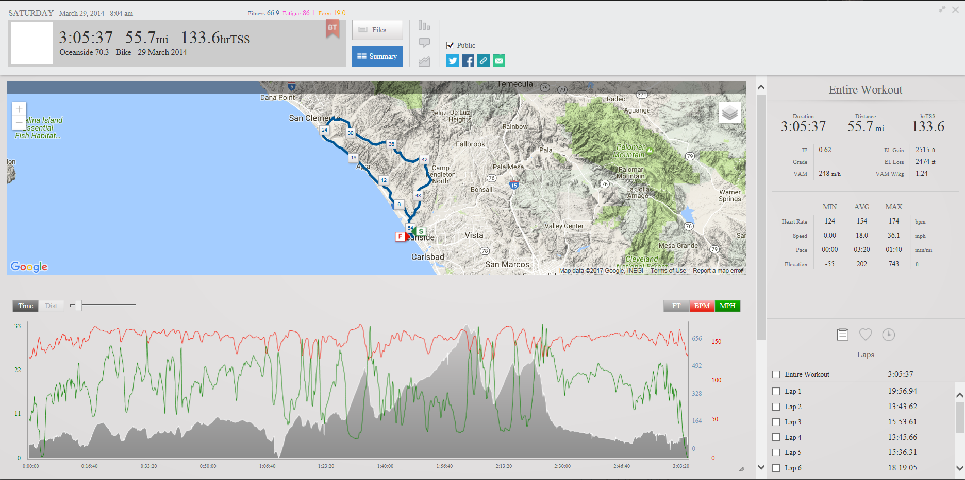

Here are the 2015 results. This was a week after the tri camp in Arizona, so I was a little tired going in.
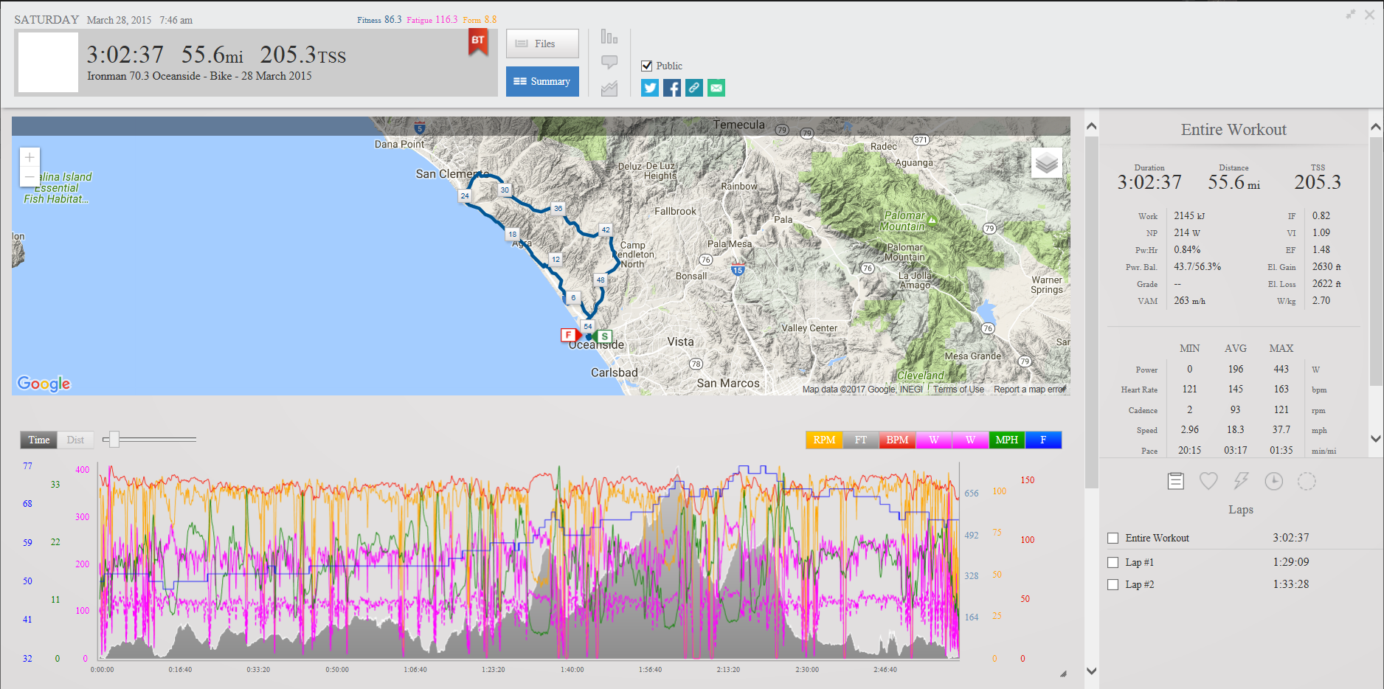

I’ve gotten a little better at riding hills since the last 2 times I raced here. My fitness is a lot higher and I’ll have a better taper this time, so I think I should be able to significantly improve my bike time here. My goals are to stay tucked in aero when I can, hit the hills hard but not burn matches, and keep fueling for the run.

I think my FTP is a bit higher than 260 (think it’s 270-280) so not sure what wattage I’ll go for. If it’s 270, then I think I can aim for ~225-230 and hold it with fresh legs. I have to see what my HR is on the bike and keep it in check for the duration of the ride.

Here’s the BBS:
https://www.bestbikesplit.com/public/55274
I did this by NP / FTP and set it to 85% based off of FTP 260

T-2: Goal is to get in and out as fast as possible, not too concerned here.

Run: I’ve had decent success on this run in the past – it’s not too hot and it’s flat, which help me greatly.

Here are the 2014 results. I had some GI issues on the run and I was gassed.
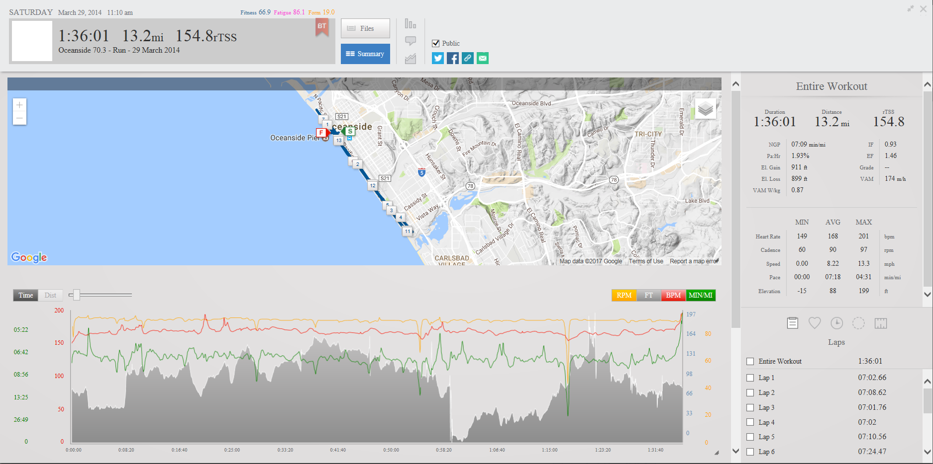

Here are the 2015 results. I think the fatigue from tri camp was starting to hit.
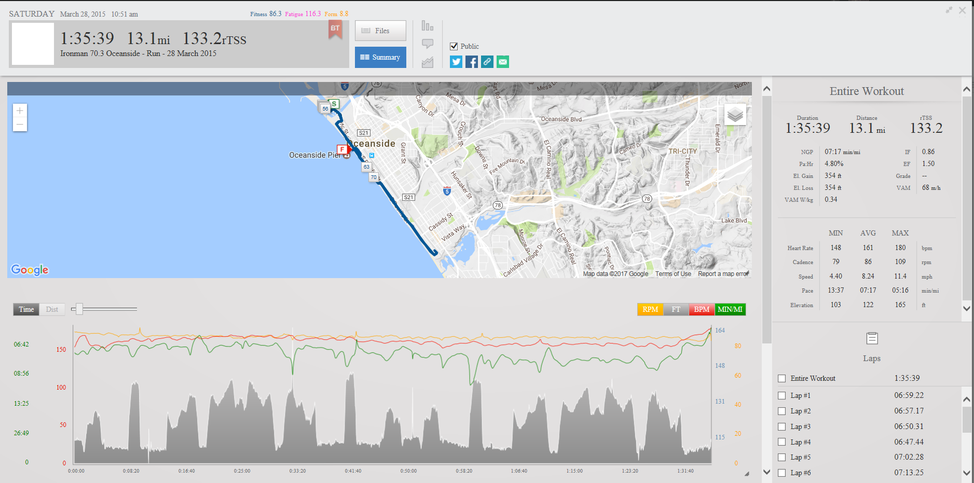

I think we can make some good improvements this time around. My fitness is a lot higher and my race runs have been getting better, so we’ll see what I can do. Goal here is to maintain and save any surges towards the end while keeping the fueling up.

Overall, I'm ready to crush this race and have fun.

